Script for the first assignment of Filtering and Identification by 1
Niels Uitterdijk, December '17. 1
Load data 1
Model parameters 1
State space description of simplified rocket dynamics 1
Descretised model of simplified rocket dynamics 1
Run the descrete model 1
Plot outcome 2

Script for the first assignment of Filtering and Identification by

Niels Uitterdijk, December '17.
clear
close all
clc

Load data
load('rocket.mat')

Model parameters
dt = 0.1; % [s]
m = 100; % [kg]
g = 9.81; % [m/s/s]
y(1) = 0; % [m]
d_approx = 1700; % [N]

State space description of simplified rocket dynamics
A_c = [0 1; 0 0];
B_c = [0 0 0; 1/m -1 -1/m];
C_c = [1 0];
D_c = 0;
% Silly comment on how x = [y dy/dt]'

Descretised model of simplified rocket dynamics
A = [1 dt;0 1];
B = [dt^2/(2*m) -dt^2/2 -dt^2/(2*m); dt/m -dt -dt/m];
C = [1 0];
D = 0;

Run the descrete model
[Y,T,X] = lsim(SYS,U,T,X0)
rocket_dis = ss(A,B,C,D);
rocket_con = ss(A_c,B_c,C_c,D_c);
T = linspace(0,length(dtrue)*dt,length(dtrue));
[Y, T, X] = lsim(rocket_con,u',T,[]);

Plot outcome
figure
plot(T,Y)
hold on
plot(T,y)
legend('Model Prediction','Data')
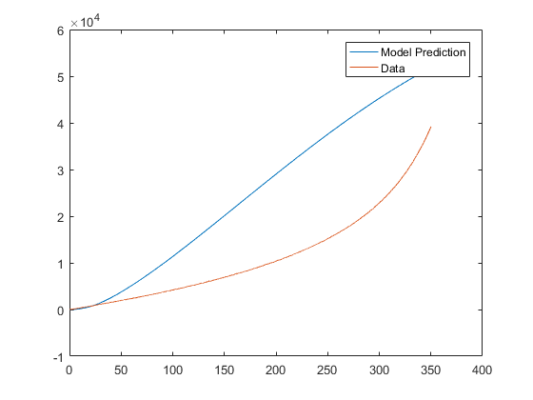
The two lines do indeed intersect but only in the very beginning. After quite a bit of time the model is not very accurate.

